Gosforth Schools’ Trust
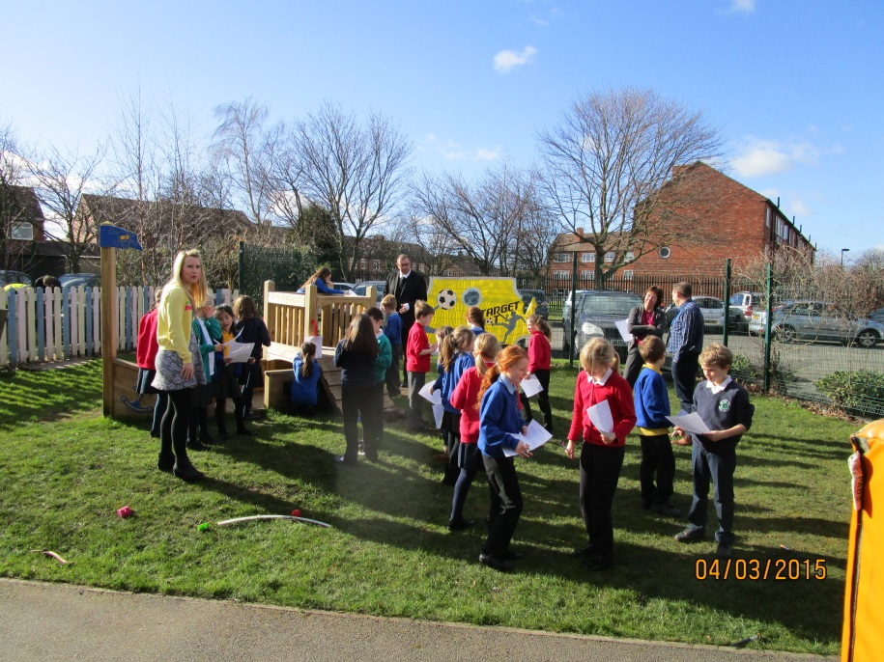
Trust Develops New School Council
The vision of Gosforth Schools’ Trust is to provide effective, supportive, quality education for every child in our schools. This aim cannot be achieved without the active involvement of our children. Following discussions across all the schools the pupils decided that they would like to form a Trust School Council, following discussions the Trust Board of Directors thought this was a good idea and a great way to ensure the pupils has a collective voice that is heard and can help us in the ongoing development of the Trust.

The Trust School Council consists of two representatives from each school. For the First schools the pupils were chosen from Year 3 and from our two Middle schools the pupils were chosen from Year 5.
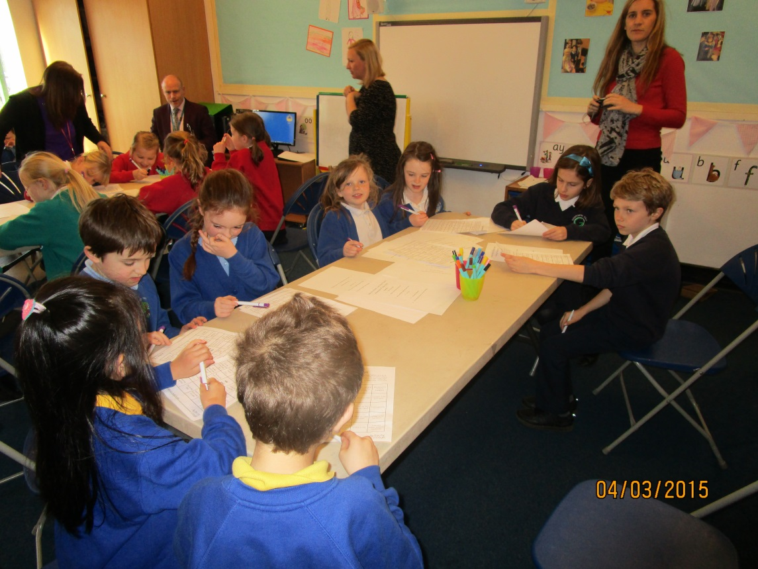
Amongst the pupils representing the schools are:
Evie Harrison | Maliah Kay
Ellen Chen | Ahmed Mohammed
Will Henderson | Ruby Davison
Millie Matthew | Sebastian Dean
Adam Chetcuti | Keira Smith
Ellison Burke | Jacob Smith
Jessica Newton | Louise Johnson
Charlotte Cawthray | Anna Morgan
Emma Ghazal | Abbie Keddy
The children were invited to the first meeting of the Council which took place at Regent Farm First School on the 4th March. The first meeting was an opportunity for the children to meet one another and understand what the Trust was about and the role of the School Council.
The Chair of the Trust Board of Directors George Snaith and the Trust Business Manager Julie McManus explained the work of the Trust and how it would benefit the schools. The children took turns to introduce themselves and their schools using an ice breaker game which was great fun.
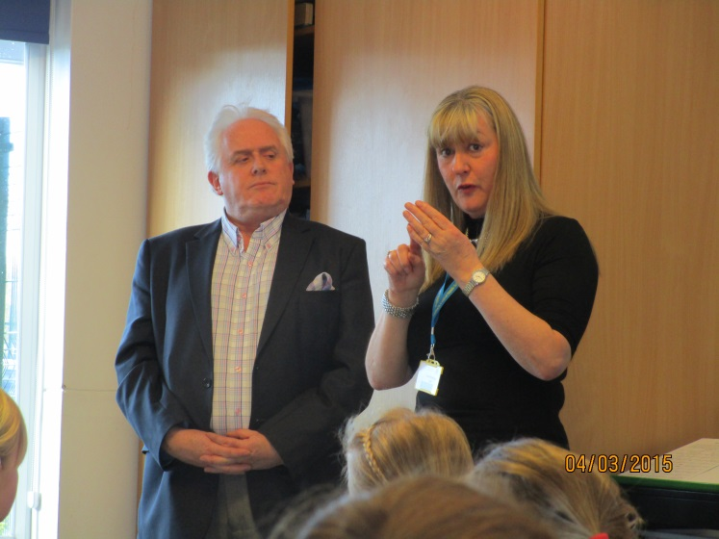
The main outcome of the first meeting was the agreement by the School Council members to organise a tour of the schools that make up the Trust. The children mind mapped possible ideas for their school and specific activities or achievements of their school they could emphasise when the tour takes place at the end of the academic year.

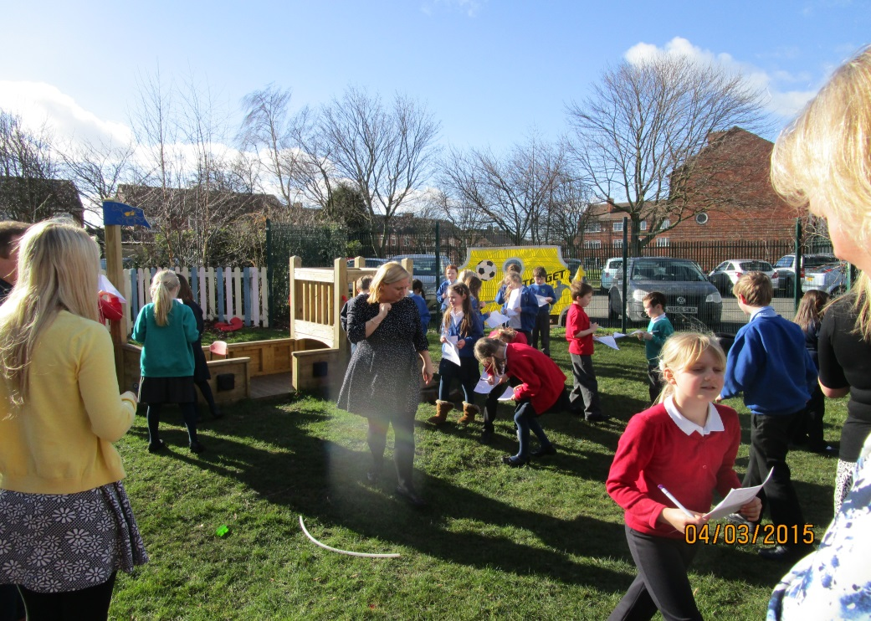
The School Council will meet again early in the summer term. This time the venue will be Gosforth Central Middle School.

