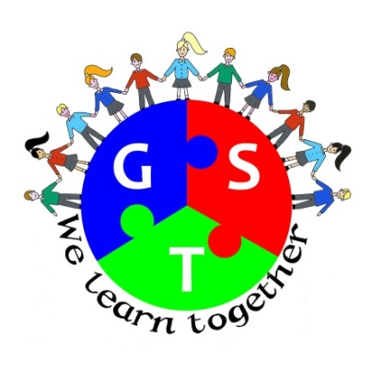

Gosforth Schools Trust
Autumn Term 2015-16 Newsletter

Welcome from the Chair
Welcome to the Gosforth Schools’ Trust Autumn Term newsletter. As always this has been a busy term for all of our schools, I am sure that staff and pupils are looking forward to the Christmas break. For the Trust this has also been a busy time trying to make sure that we continue to add value to our schools and getting to grips with new procedures at the end of our first year.
One of the developments that I am really pleased about is the Schools Trust Council; where two pupils from each school Council meet each term to think about collaboration and sharing. This term they worked on their ‘High Five’ Trust Values which are:
• Friendly and Supportive
• Teamwork
• Respect
• Participation
• Communication
Having shared this with the Board I think we should all be adopting these values in all of our Trust work.
May I take the opportunity to wish everyone a Happy Christmas and I look forward to a very productive 2016.
Best regards
George Snaith
Chair

Update from the Vice Chair

Update from the Vice Chair
Subject Leaders’ Networks
We are delighted to be able to report that we have now established effective networks for our teachers who are subject leaders. Before the formation of the Trust, we already had close working relationships in some subject areas and in some clusters but we have now established a Trust-wide network for almost every subject. This means that we are able to share best practice, expertise, resources and financial costs across the Trust and within clusters. The most recent group to form was the English Network and this was led by Dr Maureen Hughes, a fantastic and inspiring consultant with whom some of us have worked in the past. Through these meetings we are able to ensure that we keep up to date with national and local developments and expectations in each subject area. At the English meeting there was a sharp focus on the requirements of the new curriculum and how these will be assessed at Year 2 and Year 6. Similar discussions have taken place in other subject areas too and more meetings are planned for other subjects in the coming term.

Shakespeare Schools’ Festival
Some of our schools took part in the Shakespeare Schools’ Festival this term. This project culminated in performances at the Northern Stage where pupils took to the stage with impressive and dramatic results. Well done to all who took part.
Best wishes

Helen McKenna
Vice Chair and Head Teacher Broadway East First School

Hello from our Business Manager

Hello from our Business Manager
As always we are are striving to improve our communications across the Trust area and with all of our stakeholders. During this term the governing bodies of each of our schools has been visited by either me or the Chairman of the Board; in some cases the governors got to meet both of us at the same time! The main purpose of the visits was to update the members of the work of the Trust and let them know our plans for the forthcoming year. Our visits have been welcomed and we’ve received very useful feedback from them and also gained some new and useful contacts. We do have a couple of schools left to visit in January and we are looking forward to meeting them and receiving their feedback on our work to date.

We’ve also met up for the second time with some of the Trust Foundation Governors. The meeting was very useful. The Foundation Governors are looking to get more involved with the work of the Trust and plans are in place to ensure this happens.

Our website is live and you can visit it by clicking here. We are keen to hear your views on it – why not drop me an email and let me know what you think about it. We are also on Twitter why not follow us on @GosforthGST and keep up to date with the activities and achievements of our pupils and staff.

The Trust submitted its first official year – end accounts, for the period ended 31st March 2015, to Companies House on the 17th December. The Trust is a registered company with exempt charitable status which means we must operate like a business. We have engaged a firm of accountants to support us with the development of our accounts and we are very lucky to also be supported by Sharon Coull, a qualified accountant who is a member of South Gosforth First School Governing Body. A copy of the accounts will be uploaded onto our website once they have been approved by the Board of Directors and accepted by Companies House.

We have been looking at how we purchase our everyday supplies such as copying and printing, office stationery etc. with a view to finding cost efficiencies. This work is carried out by the GST Office Managers Group who meet once per term. Negotiations with current and potential new suppliers are ongoing and we are confident this work will bring about some savings to each school.

In November we hosted the inaugural meeting of the Newcastle City Trust Managers Group. This group is made up of representatives, either the Trust Business Manager or the Trust Lead Person, from the Foundation Trusts that operate across the Newcastle City Council area. The first meeting was a forum for sharing good practice and to identify the variety of skills available to call upon across the group as it was clear that we are all in the same steep learning curve.

Recently I attended a free event where the main speaker was from the ASCL (Association of School and College Leaders). The ASCL presentation was entitled ‘The challenges ahead’ and laid out the every changing landscape for our schools in a very clear way. Key areas were about strategic planning, working collaboratively across schools, joint procurement and benchmarking. I am pleased to say that we have begun to tackle most of these key challenges and will continue to do so in the coming year.

The Board of Directors is beginning the work on developing a five year strategic plan for the Trust and will be holding a workshop in January. The Board will be supported by some of the Foundation Governors and other members of the partner schools governing bodies.

News from our schools – our summer newsletter contained lots of lovely stories about the various projects and activities our pupils were involved in over the summer term. You can always find out more about the work and achievements of our schools by visiting their websites just click on the school logo below.

May I take this opportunity to wish you all a Very Merry Christmas and a peaceful and prosperous new year.
Kind Regards

Julie McManus
Business Manager Gosforth Schools’ Trust

